**CS110 Computer Science Fundamentals Midterm 1 20th March 2023**

*Name: _________________________________*

*Please observe the Emory College Honor Code while taking this test. NOTE: You* ***must*** *show all work; the final answer alone will give you little credit, if any.*

1. (4 points) Choose one correct answer: the smallest basic unit of data representation and computing is:

(a) byte

(b) word

(c) bit

(d) cpu

(e) boolean

2. (8 points) What is the value of the output (Y) of the circuit shown below when

**(a)** A=0, B=0; C=1 and **(b)** A=1; B=0; C=0

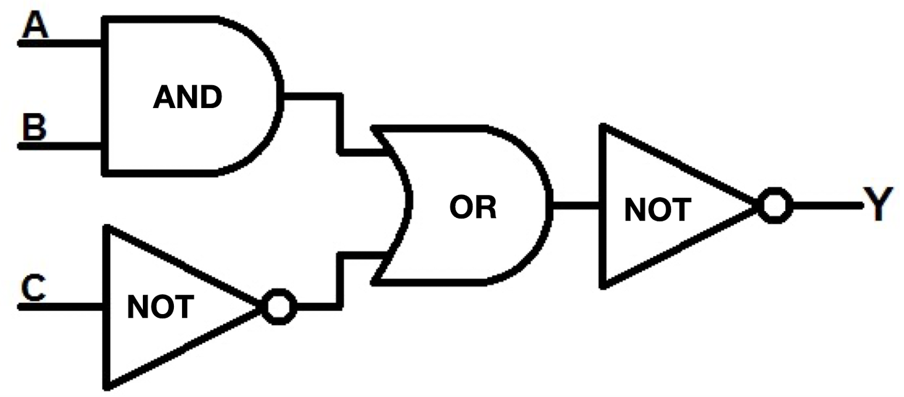

3. (6 points) What is the decimal value of the 8 bit integer 11110111

4. (6 points) What is the binary representation, using 12 bits, of the decimal integer 467

5. (12 points) What are the values of the variables on the left hand side after these Python statements are executed?

1. eye = 37 + 91 // 5 * 32
2. eyeeye = 37 + 9 % 5 * 32
3. pi = 217 % 5 + 1.14
4. pad = ‘s’ + ‘b’ + ‘23’

6. (8 points) Replace the stars below so that this Python segment prints “Yes” if the input begins and ends with the same character, and “No” otherwise. You should replace *** in each place shown with your own code

ss = input(“Please enter a word or any sequence of characters”)

el = len(ss)

bee = 0

zee = ***

if ss[bee] == *** :

print (“***”)

else:

print (“***”)

print (“That’s all folks”)

7. (10 points) What does this Python code segment print?

k = 1

s = 0

while k <= 100:

if k % 23 == 0 :

s = s + 1

elif k % 33 == 0:

s = s – 1

k = k + 1

print (s)

8. (12 points) Modify the program below (fill in statements where indicated) so that it prints “Yum” after every 3 "Chomp"s and “Yummy” after every 5 “Chomp”s

k = 0

while k < 100:

k = k + 1

print (“Chomp”)

*** FILL IN STATEMENTS HERE ***

print(“Done, close the fridge”)

9. (14 points) Give example inputs for the program below: **(a)** Give one example input that causes the program to print “Yes” and **(b)** give another example input that causes it to print “No”

def mid3 (s1):

n = len(s1) -1

s2 = ‘’

while (n >= 0):

s2 = s2 + s1[n]

n = n -1

return (s2)

x = input (“Please enter a word”)

y = mid3 (x)

if (x == y):

print(“Yes”)

else:

print (“No”)

10. (20 points) Define a function to accept two integers and return the first raised to the power of the second. Write a program to ask the user to input a two numbers, invoke your power function, and print the value it returns. The function should work by repeated multiplication, not by simply using built-in operations or functions